**LOVELY PHOTOGRAPHY WEB**

# A PROJECT REPORT

***Submitted by***

# Y. CHANDRIKA NAIDU

***in partial fulfilment for the award of the degree*** ***of***

# BACHELOR OF TECNOLOGY

**IN**

**COMPUTER SCIENCE AND ENGINEERING**

**SPECIALIZATION IN ARTIFICIAL INTELLIGENCE AND MACHINE**

## LEARNING



# Lovely Professional University, Punjab

**OCTOBER 2024**

**Lovely Professional University, Punjab**

# BONAFIDE CERTIFICATE

Certified that this project report **“…….LOVELY PHOTOGRAPHY WEB………”**

## is the bonafide work of “…………..Y. CHANDRIKA NAIDU .…………...”

who carried out the project work under my supervision.

**SIGNATURE**

**Dr. Jaibir Singh**

**ABSTRACT-**

### Lovely Photography

### Project Overview:

"Lovely Photography" is a portfolio website that showcases a curated selection of stunning photographic works, ranging from portraits and landscapes to creative conceptual shots. The site is designed to highlight the beauty and story behind each image while offering an elegant, user-friendly browsing experience.

### Project Objectives:

• **Showcase Photography Portfolio**: Provide a platform to display a diverse collection of photographs in a visually appealing way, categorizing images by themes or genres.

• **Enhance User Experience**: Design an intuitive and accessible layout to make navigation easy, allowing users to browse images seamlessly and appreciate the aesthetic without distractions.

• **Build Brand Identity**: Create a unique and memorable brand aesthetic that reflects the style, values, and vision of the photographer, fostering a recognizable and trustworthy online presence.

• **Attract Potential Clients**: Include features like contact information, client testimonials, and a booking or inquiry form to convert site visitors into clients.

• **Optimize for Search Engines**: Ensure the website is SEO-friendly to increase visibility in search results, helping photography enthusiasts and potential clients discover the portfolio.

### Expected Outcomes:

• **Increased Online Visibility**: Higher search engine rankings and more organic traffic from people searching for photography services or inspiration, leading to a growing online presence.

• **Engagement and Interaction**: Enhanced user engagement through well-structured galleries, encouraging users to explore multiple pages, leave feedback, or connect through social media links.

• **Client Inquiries and Bookings**: A steady stream of inquiries or bookings from potential clients who are interested in hiring or collaborating, leading to new business opportunities.

• **Enhanced Brand Recognition**: A polished and professional online portfolio that reflects the photographer's unique style, helping to establish a strong, memorable brand.

• **Positive User Experience**: Visitors who enjoy a seamless, aesthetic experience on the site, whether they’re using a desktop, tablet, or mobile device, making it likely they'll return and recommend the site to others.

### Conclusion:

"Lovely Photography" website will serve as a dynamic and professional online portfolio, showcasing unique photographic work and establishing a strong brand identity. Through a visually appealing, user-friendly design, it aims to captivate viewers, attract new clients, and foster meaningful connections. By achieving high visibility, engaging visitors, and offering seamless functionality across devices, this website not only highlights the artistry of the photographer but also opens doors for business growth and creative opportunities.

**TABLE OF CONTENTS**

|  |  |
| --- | --- |
| **CHAPTER NAME** | **PAGE NO.** |
| **Title Page** | **1** |
| **Bonafide Certificate** | **2** |
| **Abstract** | **3** |
| **Table of Contents** | **4** |
| **CODES** | **5-23** |
| **OUTPUTS** | **24-26** |
| **List of Symbols, Abbreviations and Nomenclature** | **27** |
| **References** | **28** |

## CODES

### “Homepage.html”- HTML file

### home.html

<!doctype html>

<html lang="en">

<head>

    <meta charset="utf-8">

    <meta name="viewport" content="width=device-width, initial-scale=1">

    <link href="https://cdn.jsdelivr.net/npm/bootstrap@5.3.0-alpha1/dist/css/bootstrap.min.css" rel="stylesheet"

        integrity="sha384-GLhlTQ8iRABdZLl6O3oVMWSktQOp6b7In1Zl3/Jr59b6EGGoI1aFkw7cmDA6j6gD" crossorigin="anonymous">

    <link rel="stylesheet" href="Homepage.css">

    <title>Photography Landing Page using HTML CSS and JavaScript - Coding Torque</title>

</head>

<body>

   <div class="hero-section">

    <div class="about-text hover-target">About</div>

    <div class="contact-text hover-target">Contact</div>

    <div class="section-center">

        <div class="container-fluid">

            <div class="row justify-content-center">

                <div class="col-12 text-center">

                    <h1>Lovely Photography</h1>

                </div>

                <div class="col-12 text-center mb-2">

                    <div class="dancing">photography</div>

                </div>

                <div class="col-12 text-center mt-4 mt-lg-5">

                    <p>

                        <span class="travel hover-target">Travel</span>

                        <span class="wildlife hover-target">Wildlife</span>

                        <span class="nature hover-target">Nature</span>

                    </p>

                </div>

            </div>

        </div>

    </div>

</div>

<div class='cursor' id="cursor"></div>

<div class='cursor2' id="cursor2"></div>

<div class='cursor3' id="cursor3"></div>

    <script src="https://cdn.jsdelivr.net/npm/bootstrap@5.3.0-alpha1/dist/js/bootstrap.bundle.min.js"

        integrity="sha384-w76AqPfDkMBDXo30jS1Sgez6pr3x5MlQ1ZAGC+nuZB+EYdgRZgiwxhTBTkF7CXvN"

        crossorigin="anonymous"></script>

    <script src="https://code.jquery.com/jquery-3.6.3.js"

        integrity="sha256-nQLuAZGRRcILA+6dMBOvcRh5Pe310sBpanc6+QBmyVM=" crossorigin="anonymous"></script>

    <script src="Homepage.js"></script>

</body>

</html>

### travel.html

<div class="travel-section">

    <div class="travel-close hover-target"></div>

    <div class="container">

        <div class="row justify-content-center">

            <div class="col-12 text-center">

                <h3>Travel</h3>

            </div>

            <div class="col-12 mt-3 text-center">

                <p><span>Nikon Z9</span></p>

            </div>

            <div class="col-12 text-center">

                <p>

                </p>

            </div>

            <div class="col-md-6 col-lg-4">

                <img src="DALL·E 2024-10-26 16.17.24 - A scenic travel destination photograph taken with a focal length of 22.5mm, aperture of ƒ_5.6, exposure time of 1_1000, and ISO 80. Capture a dramatic.webp" alt="">

            </div>

            <div class="col-md-6 col-lg-4">

                <img src="DALL·E 2024-10-26 16.16.58 - A scenic travel destination photograph taken with a focal length of 22.5mm, aperture of ƒ_5.6, exposure time of 1_1000, and ISO 80. Capture a vibrant,.webp" alt="">

            </div>

            <div class="col-md-6 col-lg-4">

                <img src="DALL·E 2024-10-26 16.16.55 - A scenic travel destination photograph taken with a focal length of 22.5mm, aperture of ƒ_5.6, exposure time of 1_1000, and ISO 80. Show a vibrant, su.webp" alt="">

            </div>

        </div>

    </div>

</div>

### wildlife.html

### <div class="wildlife-section">

### <div class="wildlife-close hover-target"></div>

### <div class="container">

### <div class="row justify-content-center">

### <div class="col-12 text-center">

### <h3>Wildlife</h3>

### </div>

### <div class="col-12 mt-3 text-center">

### <p><span>Nikon Z9</span></p>

### </div>

### <div class="col-12 text-center">

### <p>

### </p>

### </div>

### <div class="col-md-6 col-lg-4">

### <img src="Wildlife 1.jpg" alt="">

### </div>

### <div class="col-md-6 col-lg-4">

### <img src="Wildlife 2.jpg" alt="">

### </div>

### <div class="col-md-6 col-lg-4">

### <img src="Wildlife 3.jpg" alt="">

### </div>

### </div>

### </div>

### </div>

### nature.html

<div class="nature-section">

    <div class="nature-close hover-target"></div>

    <div class="container">

        <div class="row justify-content-center">

            <div class="col-12 text-center">

                <h3>Nature</h3>

            </div>

            <div class="col-12 mt-3 text-center">

                <p><span>Nikon Z9</span></p>

            </div>

            <div class="col-12 text-center">

                <p>

                </p>

            </div>

            <div class="col-md-6 col-lg-4">

                <img src="Nature 1.jpg" alt="">

            </div>

            <div class="col-md-6 col-lg-4">

                <img src="Nature 2.jpg" alt="">

            </div>

            <div class="col-md-6 col-lg-4">

                <img src="Nature 3.jpg" alt="">

            </div>

        </div>

    </div>

</div>

**about.html**

<div class="about-section">

    <div class="about-close hover-target"></div>

    <div class="section-center">

        <div class="container">

            <div class="row justify-content-center">

                <div class="col-12 text-center">

                    <img src="Cam.jpg" alt="">

                </div>

                <div class="col-lg-8 text-center mt-4">

                    <p>"Lovely Photography" is a website dedicated to showcasing beautiful and captivating photography,

                        featuring a diverse range of subjects such as landscapes, portraits, events, and candid moments.

                        The site highlights the artistry and creativity of the photographer, offering visitors a portfolio

                        that reflects unique perspectives and styles. Users can browse through galleries, learn about the

                        photography services offered (such as portrait sessions or event coverage), and find information about

                        prints for sale. </p>

                </div>

### contact.html

<div class="contact-section">

    <div class="contact-close hover-target"></div>

    <div class="section-center">

        <div class="container">

            <div class="row justify-content-center">

                <div class="col-12 text-center">

                    <a href="#" class="hover-target"></a>

                </div>

                <div class="col-12 text-center social mt-4">

                    <a href="#" class="hover-target">Instagram</a>

                    <a href="#" class="hover-target">Twitter</a>

                    <a href="#" class="hover-target">Facebook</a>

                </div>

### “Homepage.css”- CSS file

@import url('https://fonts.googleapis.com/css?family=Poppins:100,100i,200,200i,300,300i,400,400i,500,500i,600,600i,700,700i,800,800i,900,900i');

@import url('https://fonts.googleapis.com/css?family=Dancing+Script:400,700');

body{

    font-family: 'Poppins', sans-serif;

    font-weight: 300;

    font-size: 15px;

    line-height: 1.6;

    color: #fff;

    background-color: #1f2029;

    overflow: hidden;

    height: 100vh;

    -webkit-transition: all 300ms linear;

    transition: all 300ms linear;

    perspective: 800px;

}

a {

    cursor: pointer;

}

a:hover {

    text-decoration: none;

}

::selection {

    color: #c4c3ca;

    background-color: #000;

}

::-moz-selection {

    color: #c4c3ca;

    background-color: #000;

}

.cursor,

.cursor2,

.cursor3{

    position: fixed;

    border-radius: 50%;

    transform: translateX(-50%) translateY(-50%);

    pointer-events: none;

    left: -100px;

    top: 50%;

    mix-blend-mode: difference;

    -webkit-transition: all 300ms linear;

    transition: all 300ms linear;

}

.cursor{

    background-color: #fff;

    height: 0;

    width: 0;

    z-index: 99999;

}

.cursor2,.cursor3{

    height: 36px;

    width: 36px;

    z-index:99998;

    -webkit-transition:all 0.3s ease-out;

    transition:all 0.3s ease-out

}

.cursor2.hover,

.cursor3.hover{

    -webkit-transform:scale(2) translateX(-25%) translateY(-25%);

    transform:scale(2) translateX(-25%) translateY(-25%);

    border:none

}

.cursor2{

    border: 2px solid #fff;

}

.cursor2.hover{

    background: rgba(255,255,255,1);

    border-color: transparent;

}

@media screen and (max-width: 1200px){

    .cursor,.cursor2,.cursor3{

        display: none

    }

}

.hero-section {

    position: relative;

    width: 100%;

    display: block;

    overflow: hidden;

    height: 100vh;

    background-image: url('http://www.ivang-design.com/svg-load/portfolio/photo.jpg');

    background-size: cover;

    background-position: center;

    transform: scale(1) rotateX(0);

    box-shadow: 0 0 40px rgba(0,0,0,0.2);

    -webkit-transition: all 300ms linear;

    transition: all 300ms linear;

    -webkit-transition-delay: 400ms;

    transition-delay: 400ms;

    transform-origin: center top;

}

.hero-section h1{

    color: #fff;

    font-size: 5vw;

    line-height: 1;

    font-weight: 900;

}

.hero-section .dancing{

    font-family: 'Dancing Script', cursive;

    letter-spacing: 1px;

    color: #866BAF;

    font-size: 26px;

    line-height: 1;

    font-weight: 700;

}

@media screen and (max-width: 580px){

    .hero-section .dancing{

        font-size: 18px;

    }

}

.hero-section p{

    font-size: 15px;

    line-height: 20px;

    font-weight: 500;

    color: #fff;

    letter-spacing: 1px;

}

.hero-section p span{

    margin-left: 15px;

    margin-right: 15px;

    position: relative;

    display: inline-block;

    cursor: pointer;

    padding-bottom: 35px;

}

.hero-section p span:before {

    position: absolute;

    content: '';

    bottom: 10px;

    left: 50%;

    height: 30px;

    width: 30px;

    margin-left: -15px;

    z-index: -1;

    background-repeat: no-repeat;

    background-position: center;

    background-size: 30px 30px;

    background-image: url('http://www.ivang-design.com/svg-load/portfolio/down.svg');

    opacity: 0.2;

    -webkit-transition: all 200ms linear;

    transition: all 200ms linear;

}

.hero-section p span:hover:before {

    opacity: 1;

    bottom: 5px;

}

body.about-on .hero-section {

    transform: scale(0.75);

    -webkit-transition-delay: 0ms;

    transition-delay: 0ms;

}

body.contact-on .hero-section {

    transform: scale(0.75);

    -webkit-transition-delay: 0ms;

    transition-delay: 0ms;

}

body.travel-on .hero-section {

    transform: rotateX(-10deg);

    -webkit-transition-delay: 0ms;

    transition-delay: 0ms;

}

body.wildlife-on .hero-section {

    transform: rotateX(-10deg);

    -webkit-transition-delay: 0ms;

    transition-delay: 0ms;

}

body.nature-on .hero-section {

    transform: rotateX(-10deg);

    -webkit-transition-delay: 0ms;

    transition-delay: 0ms;

}

.about-text {

    position: absolute;

    font-size: 17px;

    line-height: 20px;

    font-weight: 700;

    color: #fff;

    letter-spacing: 2px;

    top: 50%;

    left: 40px;

    cursor: pointer;

    z-index: 2;

    -webkit-writing-mode: vertical-lr;

    writing-mode: vertical-lr;

    transform: translateY(-50%);

    -webkit-transition: all 200ms linear;

    transition: all 200ms linear;

}

.about-text:before {

    position: absolute;

    content: '';

    top: 50%;

    left: -25px;

    height: 30px;

    width: 30px;

    margin-top: -15px;

    z-index: -1;

    background-repeat: no-repeat;

    background-position: center;

    background-size: 30px 30px;

    background-image: url('http://www.ivang-design.com/svg-load/portfolio/left.svg');

    opacity: 0.2;

    -webkit-transition: all 200ms linear;

    transition: all 200ms linear;

}

.about-text:hover:before {

    opacity: 1;

    left: -30px;

}

.about-section {

    position: fixed;

    top: 0;

    left: 0;

    width: 100%;

    display: block;

    overflow: hidden;

    height: 100vh;

    background-color: rgba(31,32,41,1);

    transform: translateX(-100%);

    -webkit-transition: all 300ms linear;

    transition: all 300ms linear;

    z-index: 10;

}

body.about-on .about-section {

    transform: translateX(0);

    -webkit-transition-delay: 400ms;

    transition-delay: 400ms;

}

.about-close {

    position: absolute;

    top: 20px;

    right: 20px;

    width: 30px;

    display: block;

    overflow: hidden;

    height: 30px;

    -webkit-transition: all 200ms linear;

    transition: all 200ms linear;

    background-repeat: no-repeat;

    background-position: center;

    background-size: 36px 36px;

    background-image: url('http://www.ivang-design.com/svg-load/portfolio/close.svg');

    cursor: pointer;

    z-index: 11;

}

.about-close:hover {

    transform: rotate(90deg);

}

.section-center {

    position: absolute;

    width: 100%;

    left: 0;

    top: 50%;

    transform: translateY(-50%);

    z-index: 1;

}

.about-section img {

    width: 100px;

    height: 100px;

    border-radius: 4px;

    display: block;

    margin: 0 auto;

    box-shadow: 0 0 20px rgba(0,0,0,0.15);

}

.about-section p span {

    font-family: 'Dancing Script', cursive;

    letter-spacing: 1px;

    color: #866BAF;

    font-size: 25px;

    font-weight: 400;

}

.contact-text {

    position: absolute;

    font-size: 17px;

    line-height: 20px;

    font-weight: 700;

    color: #fff;

    letter-spacing: 2px;

    top: 50%;

    right: 40px;

    cursor: pointer;

    z-index: 2;

    -webkit-writing-mode: vertical-lr;

    writing-mode: vertical-lr;

    transform: translateY(-50%) rotate(180deg);

    -webkit-transition: all 200ms linear;

    transition: all 200ms linear;

}

.contact-text:before {

    position: absolute;

    content: '';

    top: 50%;

    left: -25px;

    height: 30px;

    width: 30px;

    margin-top: -15px;

    z-index: -1;

    background-repeat: no-repeat;

    background-position: center;

    background-size: 30px 30px;

    background-image: url('http://www.ivang-design.com/svg-load/portfolio/left.svg');

    opacity: 0.2;

    -webkit-transition: all 200ms linear;

    transition: all 200ms linear;

}

.contact-text:hover:before {

    opacity: 1;

    left: -30px;

}

.contact-section {

    position: fixed;

    top: 0;

    left: 0;

    width: 100%;

    display: block;

    overflow: hidden;

    height: 100vh;

    background-color: rgba(31,32,41,1);

    transform: translateX(100%);

    -webkit-transition: all 300ms linear;

    transition: all 300ms linear;

    z-index: 10;

}

body.contact-on .contact-section {

    transform: translateX(0);

    -webkit-transition-delay: 400ms;

    transition-delay: 400ms;

}

.contact-close {

    position: absolute;

    top: 20px;

    right: 20px;

    width: 30px;

    display: block;

    overflow: hidden;

    height: 30px;

    -webkit-transition: all 200ms linear;

    transition: all 200ms linear;

    background-repeat: no-repeat;

    background-position: center;

    background-size: 36px 36px;

    background-image: url('http://www.ivang-design.com/svg-load/portfolio/close.svg');

    cursor: pointer;

    z-index: 11;

}

.contact-close:hover {

    transform: rotate(90deg);

}

.contact-section a{

    margin: 0 auto;

    font-size: 32px;

    font-weight: 900;

    letter-spacing: 1px;

    color: #fff;

  display: inline-block;

}

.contact-section .social a{

    margin-left: 8px;

    margin-right: 8px;

    font-size: 15px;

    font-weight: 600;

    letter-spacing: 1px;

    color: #866BAF;

}

@media screen and (max-width: 580px){

    .contact-section a{

        font-size: 17px;

    }

    .contact-section .social a{

        margin-left: 3px;

        margin-right: 3px;

        font-size: 13px;

        letter-spacing: 0;

    }

}

.travel-section,

.wildlife-section,

.nature-section {

    position: fixed;

    top: 100%;

    left: 0;

    padding: 100px 0;

    width: 100%;

    height: 100vh;

    display: block;

    overflow-x: hidden;

    overflow-y: auto;

    background-color: rgba(31,32,41,1);

    -webkit-transition: all 300ms linear;

    transition: all 300ms linear;

    z-index: 10;

}

.travel-close,

.wildlife-close,

.nature-close {

    position: absolute;

    top: 20px;

    right: 20px;

    width: 30px;

    display: block;

    overflow: hidden;

    height: 30px;

    -webkit-transition: all 200ms linear;

    transition: all 200ms linear;

    background-repeat: no-repeat;

    background-position: center;

    background-size: 36px 36px;

    background-image: url('http://www.ivang-design.com/svg-load/portfolio/close.svg');

    cursor: pointer;

    z-index: 11;

}

.travel-close:hover,

.wildlife-close:hover,

.nature-close:hover {

    transform: rotate(90deg);

}

body.travel-on .travel-section {

    top: 0;

    -webkit-transition-delay: 400ms;

    transition-delay: 400ms;

}

body.wildlife-on .wildlife-section {

    top: 0;

    -webkit-transition-delay: 400ms;

    transition-delay: 400ms;

}

body.nature-on .nature-section {

    top: 0;

    -webkit-transition-delay: 400ms;

    transition-delay: 400ms;

}

.travel-section img,

.wildlife-section img,

.nature-section img {

    margin-top: 30px;

    width: 100%;

    height: auto;

    display: block;

    border-radius: 4px;

    box-shadow: 0 0 20px rgba(0,0,0,0.4);

}

.travel-section h3,

.wildlife-section h3,

.nature-section h3 {

    font-size: 44px;

    line-height: 1.3;

    font-weight: 700;

    letter-spacing: 1px;

    color: #fff;

}

.travel-section p,

.wildlife-section p,

.nature-section p {

    font-size: 14px;

    line-height: 1.7;

    letter-spacing: 1px;

}

.travel-section p span,

.wildlife-section p span,

.nature-section p span {

    font-size: 20px;

    line-height: 1.3;

    font-weight: 700;

    color: #866BAF;

}

.link-to-portfolio {

      position: fixed;

    bottom: 30px;

    right: 30px;

    z-index: 200;

    cursor: pointer;

    width: 50px;

    height: 50px;

    text-align: center;

    border-radius: 3px;

    background-position: center center;

    background-size: 65%;

  background-repeat: no-repeat;

    background-image: url('https://assets.codepen.io/1462889/fcy.png');

    box-shadow: 0 0 0 2px rgba(255,255,255,.1);

    transition: opacity .2s, border-radius .2s, box-shadow .2s;

    transition-timing-function: ease-out;

}

.link-to-portfolio:hover {

    opacity: 0.8;

    border-radius: 50%;

    box-shadow: 0 0 0 20px rgba(255,255,255,.1);

}

### “Homepage.js”- JavaScript file

(function ($) {

    "use strict";

    document.getElementsByTagName("body")[0].addEventListener("mousemove", function (n) {

      t.style.left = n.clientX + "px",

        t.style.top = n.clientY + "px",

        e.style.left = n.clientX + "px",

        e.style.top = n.clientY + "px",

        i.style.left = n.clientX + "px",

        i.style.top = n.clientY + "px"

    });

    var t = document.getElementById("cursor"),

      e = document.getElementById("cursor2"),

      i = document.getElementById("cursor3");

    function n(t) {

      e.classList.add("hover"), i.classList.add("hover")

    }

    function s(t) {

      e.classList.remove("hover"), i.classList.remove("hover")

    }

    s();

    for (var r = document.querySelectorAll(".hover-target"), a = r.length - 1; a >= 0; a--) {

      o(r[a])

    }

    function o(t) {

      t.addEventListener("mouseover", n), t.addEventListener("mouseout", s)

    }

    $(".about-text").on('click', function () {

      $("body").addClass("about-on");

    });

    $(".about-close").on('click', function () {

      $("body").removeClass("about-on");

    });

    $(".contact-text").on('click', function () {

      $("body").addClass("contact-on");

    });

    $(".contact-close").on('click', function () {

      $("body").removeClass("contact-on");

    });

    $(".travel").on('click', function () {

      $("body").addClass("travel-on");

    });

    $(".travel-close").on('click', function () {

      $("body").removeClass("travel-on");

    });

    $(".wildlife").on('click', function () {

      $("body").addClass("wildlife-on");

    });

    $(".wildlife-close").on('click', function () {

      $("body").removeClass("wildlife-on");

    });

    $(".nature").on('click', function () {

      $("body").addClass("nature-on");

    });

    $(".nature-close").on('click', function () {

      $("body").removeClass("nature-on");

    });

  })(jQuery);

## OUTPUTS-

### Page 1: (home.html)



### Page 2: (travel.html)

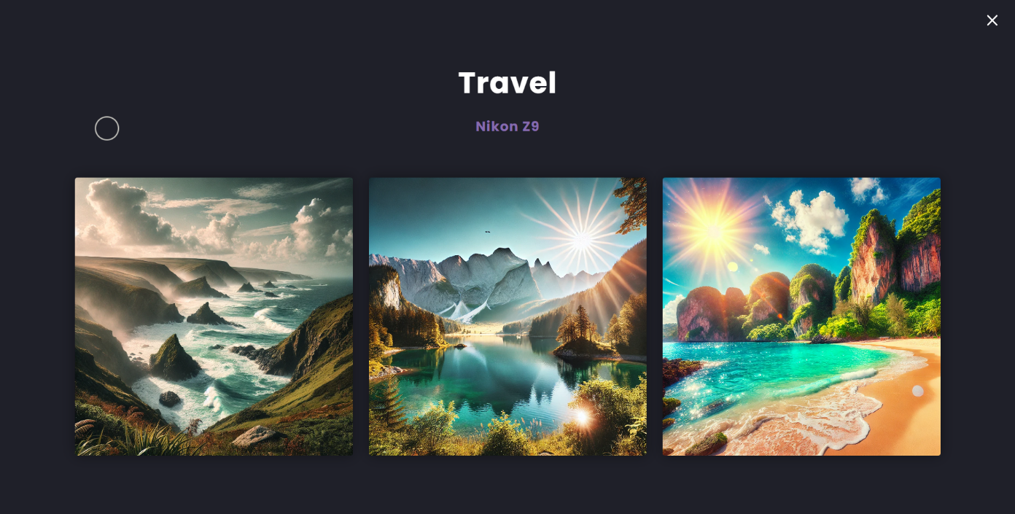

### Page 3:(wildlife.html)

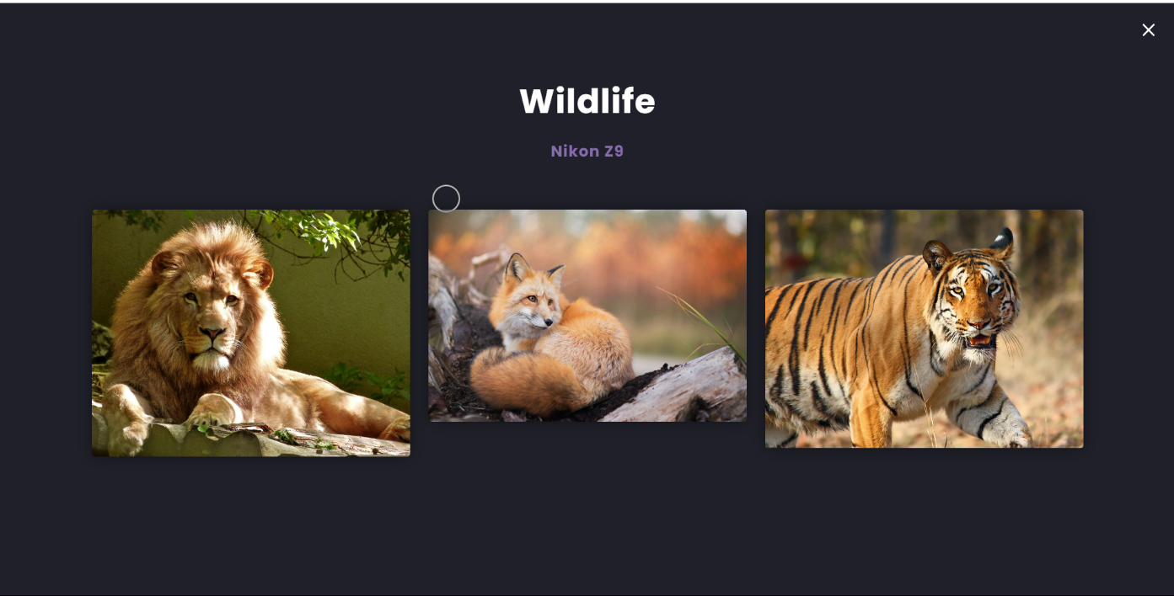

### Page 4: (nature.html)

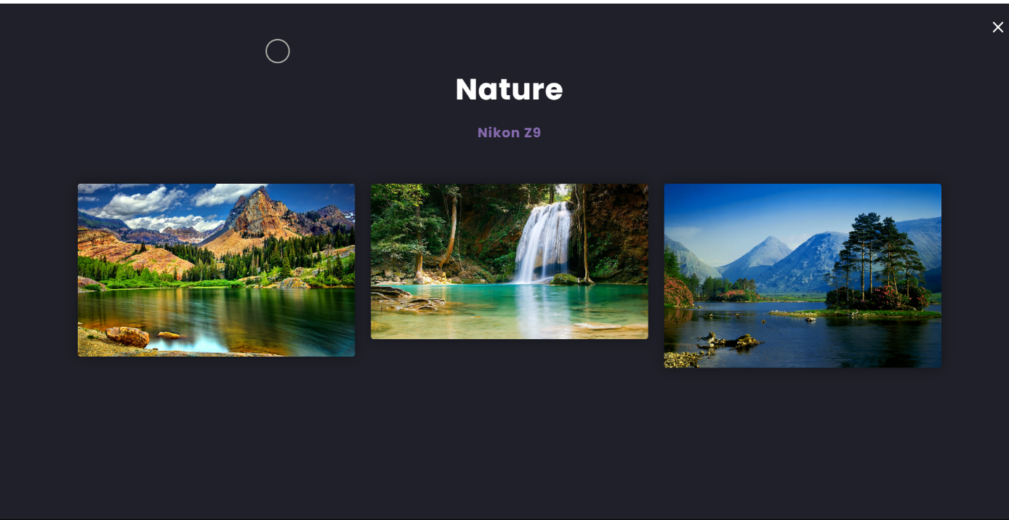

### Page 5: (aboutus.html)

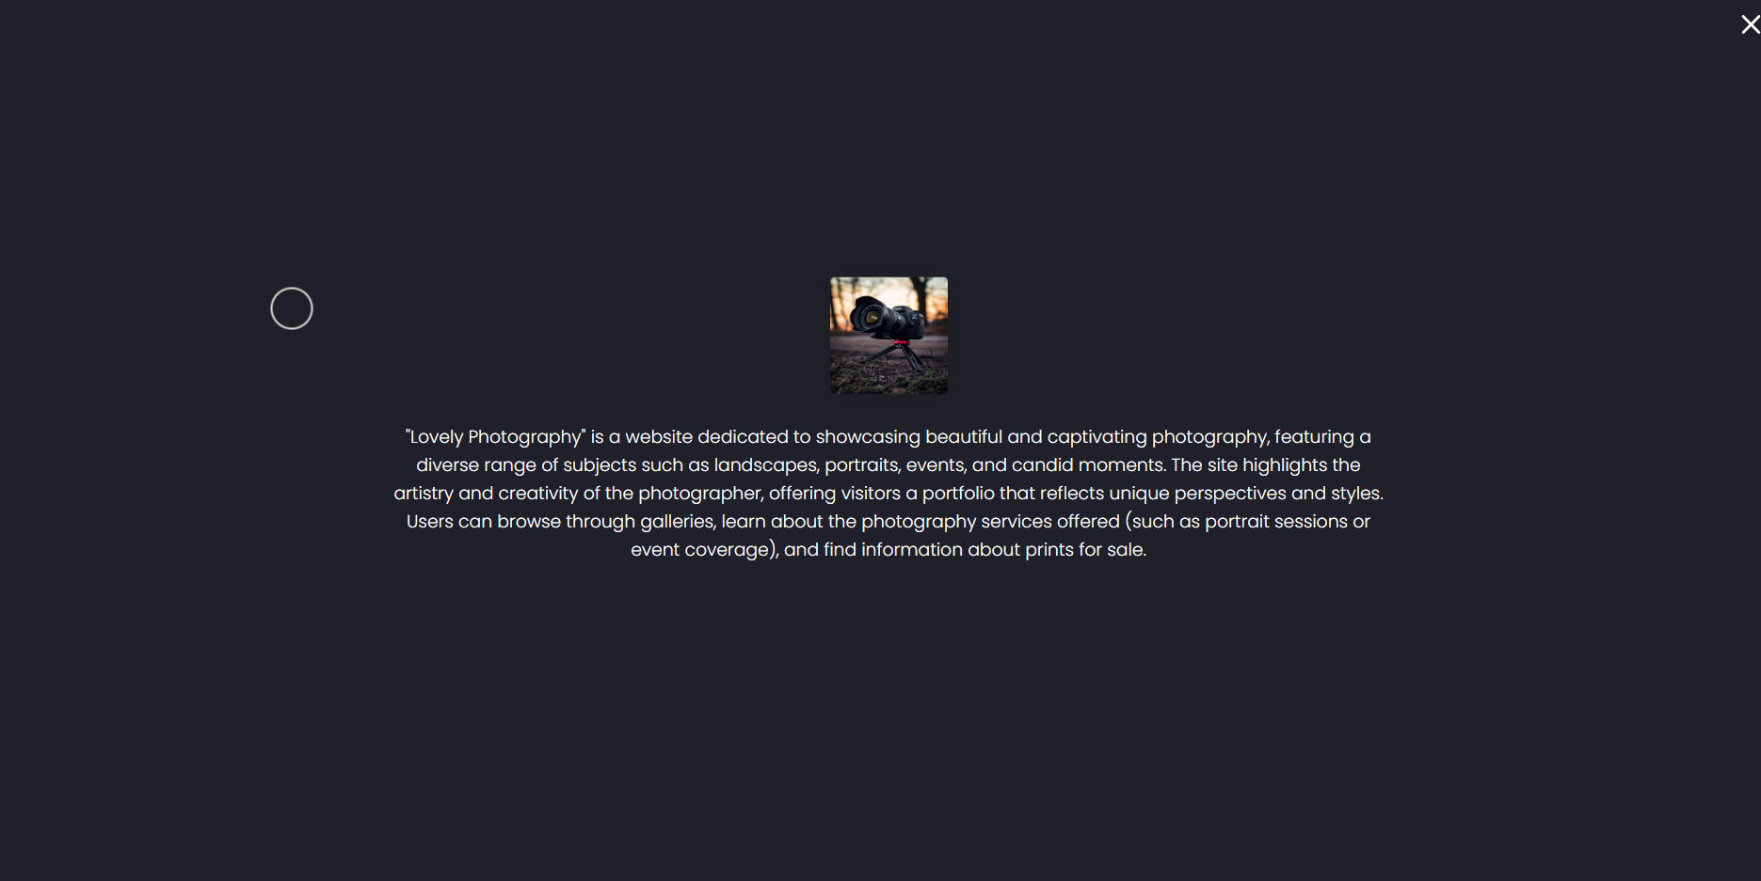

### Page 6: (contact.html)

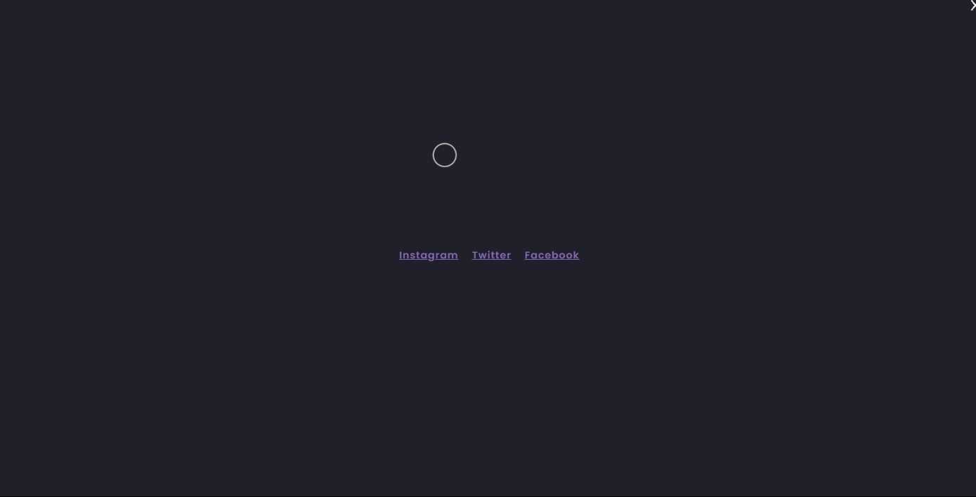

## List of Symbols, Abbreviations and Nomenclature

**Symbols and Abbreviations:**

1. **<!DOCTYPE html>**: Declaration that defines this document as an HTML5 document.
2. **<html>**: Root element that wraps all the content on the page.
3. **<head>**: Contains meta-information about the document, such as its title and links to stylesheets.
4. **<meta>**: Tag used to specify metadata about the HTML document (e.g., charset, viewport).
5. **<title>**: Sets the title of the document, which is displayed in the browser's title bar or tab.
6. **<link>**: Used to link external resources like stylesheets.
7. **<body>**: Contains the content of the HTML document that is visible to users.
8. **<header>**: Represents introductory content or navigational links.
9. **<nav>**: Defines a set of navigation links.
10. **<ul>**: Stands for "unordered list," used to create a list of items.
11. **<li>**: Stands for "list item," used within <ul> or <ol> to define each item.
12. **<strong>**: Indicates that the text is of strong importance, typically rendered in bold.
13. **<img>**: Tag used to embed images in the document.
14. **<footer>**: Represents the footer for a section or page, typically containing copyright information or links.
15. **©**: HTML entity representing the copyright symbol (©). **Nomenclature:**

* **CSS (Cascading Style Sheets)**: A stylesheet language used to describe the presentation of a document written in HTML or XML.
* **HTML (Hyper Text Markup Language)**: The standard markup language for creating web pages.
* **Viewport**: The user's visible area of a web page.
* **Metadata**: Data that provides information about other data, such as the character set or viewport settings in HTML.
* **Attributes**: Additional information provided in HTML tags, such as ‘**src’** for images or ‘**href’** for links.

## References

1. **MDN Web Docs** - Comprehensive documentation on web technologies.
2. **freeCodeCamp** - Interactive coding tutorials and exercises.
3. **Codecademy** - Interactive lessons on web development.
4. **Khan Academy** - Free courses on computer programming and web development.
5. **Coursera** - Courses from universities on web development topics.
6. **Udemy** - Wide range of paid and free courses on web development.
7. **HTML Dog** - Tutorials and references for HTML, CSS, and JavaScript.
8. **Tutorialspoint** - Tutorials on various programming languages and web technologies.
9. **GeeksforGeeks** - Tutorials, articles, and coding challenges on web development.
10. **CSS-Tricks** - Articles and guides focused on CSS and web development.

Project Done by:

Y. Chandrika Naidu

K24AN

39